Oyster Task Force Meeting
Tuesday, October 19, 2021, 1:00pm
St. Bernard Port Harbor and Terminal Building
100 Port Blvd.
Chalmette, LA 70043

I. Pledge of Allegiance
II. Roll call and introduction of guests
Voting Members Present:
Dan Coulon
Jakov Jurisic
Mitch Jurisich
Brad Robin
Brandt Lafrance
Sam Slavich
Peter Vujnovich
Willie Daisy

Voting Members Absent:
Shane Bagala
Tracy Collins
Byron Encalade
Al Sunseri
John Tesvich

Non-Voting Members Present:
Carolina Bourque
Justin Gremillion
Bryan Marie
Harry Vorhoff
Brian Lezina

Non-Voting Members Absent:
Karl Morgan

III. Peter Vujnovich motioned to approve the September 28, 2021 meeting minutes, 2nd by Willie Daisy. Motion carries.

Jakov Jurisic motioned to approve the October 19, 2021 meeting agenda, 2nd by Peter Vujnovich. Motion carries.

IV. Treasury Report
Remaining Fund Balance- $564,351
Remaining Budget Balance- $129,876
Tag sales- 78,000

The task force unanimously approved the financial report

V. Committee Reports

A. Public Private Oyster Seed Grounds Committee Meeting
The committee met on Wednesday, October 13, 2021 in Baton Rouge. The committee discussed the POLR program and fisheries disaster assistance after Hurricane Ida. Proposed doing another POLR program like what was done after Hurricane Katrina, but instead of a full blown program, modified to include cultch material only and to include reimbursement for the purchase of cultch material, discussed reef cleaning and decided to leave that to the fishermen- this proved to be administratively expensive the last time, also discussed LDWF setting up rock yards for fishermen to come and get rock, no funding available yet, have to get a fisheries disaster declared before assistance will be administered for the program, discussed preliminary dollar figures, around $100/ acre program will cost around $40M, asked that LDWF is mindful as the industry is coastal advocates, creating habitat and rebuilding what has been lost; formula in POLR program to calculate using your own oyster shells

The committee also discussed the LDWF Commission resolution to close Mardi Gras Pass, the committee voted to refrain from calling it Mardi Gras Pass and from now on refer to it as the Failed Bohemia Salinity Control Structure; after the structure is closed requested doing a study as there are other passes down the stream that may control the salinity enough without adding in the Bohemia structure, will cost $8M to close it as of today

Jakov Jurisic stated that it’s going to be extremely hard to stock pile cultch material for reimbursement

B. Enforcement Report

Grand Isle
34 counts fail to complete trip tickets
34 counts fail to maintain records
12 counts fail to report fisheries data

C. Legislative report- no report
D. Legal Committee- no report
E. Research- no report
F. Coastal Restoration- no report
G. Marketing Committee- a Facebook page is being created and the web page is about to launch, formatting for the site is approved and just awaiting launch

Gene Cavalier thanked the task force for their support and promotional items for the Weights and Measures Conference

H. Health Report- rule making for aquaculture and general cleanup for sanitary code is still under way asked that everyone be as it’s a long process, next meeting will bring a rule making calendar
I. Aquaculture Committee- no report
J. Joint Task Force Working Group- no report

VI. New Business
- The board heard a status update on the hiring of Joe Piacun as OTF legal counsel
Cole Garrett confirmed that LDWF received an executed copy of the hiring contract from Mr. Piacun this morning. Believe chairman Chip Kline sent out correspondence requesting to be involved in the shape, scope and decision making process, will take a look at the paperwork and will run it through the process
Harry Vorhoff stated that after the last meeting Chairman Kline sent a letter to Commissioner Dardenne, Attorney General Landry, Secretary Montoucet, and Mr. Block, executive counsel to the Governor to put pause on their review of any contract to hire legal counsel as it was understood that the contract’s scope of services were undefined and did not ensure consistency with the State’s Coastal Master Plan. Pursuant to Chairman Kline’s statutory authority to review and modify policies and procedures he wanted to discuss the OTF’s openness and willingness to voluntarily have discussion and limit the scope of services to ensure consistency with the State’s Coastal Master Plan.
Limit the Scope of Legal Services as follows:
- Advise the OTF on state and federal administrative proceedings
- Conduct research and prepare memoranda on state and federal administrative proceedings
- Draft and present public comments in state and federal administrative proceedings through the dissemination of factual information relative to the oyster industry
- Represent the OTF in legislative proceedings through the dissemination of factual information relative to the oyster industry
- Advise the OTF relative to LA Open Meetings Law
- All attorney client communications and work product must be made available and provided to all members of the OTF, including the non-voting members, upon request
The following activities are to be excluded from the scope of legal services:
- Lobbying for or against any matter dependent on the effect of law for the legislature or committee thereof, legal services and work product development, initiated, created, or undertaken pursuant to the contract shall not be used or made available to any member of the OTF or any third party member for the purposes of lobbying, also prohibited would be the initiation or joining of litigation or administrative challenges of any actions- actions would include seeks or issuing permits, funding for implementation of projects and those actions taken by the State or any of its local subdivisions or the federal government and any attempt to pursue litigation or administrative challenges shall be prohibited and grounds for terminating the contract, and lastly any actions that are inconsistent with the Coastal Master Plan.
Articulation or expression of concerns or issues with the Master Plan or any of its projects, programs, or policies is not considered inconsistent with the coastal master plan, this body has legislative authority to represent the interests of the oyster industry
Would like to know if the OTF would agree to these limitations on the scope of work
Mitch Jurisich stated that he has an issue when Chairman Kline gets more clout than the oyster industry, the task force is there is provide input on how the industry thinks it can work, the agency is there to protect the industry,
Jakov Jurisic motioned to put LDWF on legal notice and allow 10 business days for LDWF to act on the legal contract with Joe Piacun, 2nd by Brad Robin.
Jakov Jurisic amended the motion on the table to allow 30 days for LDWF to take action by either approving or denying the legal contract with Joe Piacun, 2nd by Brad Robin. Motion carries.
Cole Garrett stated that he received a copy of the contract this morning and it will be longer than 10 days as the AG, DOA, and Secretary still has to sign off on the contract, here to work with the industry to help craft a scope that can get through the levels of approvals that is needed, going to act upon the signed agreement and send it through the process as originally intended
Brad Robin stated that the money in the budget is money that was raised for the industry by the industry
- The board discussed USDA Covid-19 grants
Louisiana only got allocated $4 million of $700 million, asked Gene Cavalier to do some research as to why Louisiana got so little
Gene Cavalier stated that he will look further into it, will get back to the task force
C. Oyster tagging and gifting oysters
Cole Garrett stated that since you are harvesting oysters with commercial gear, presumably you are following all of the refrigeration requirements and all the other commercial requirements so for those reasons and because oyster tagging and trip tickets inform LDWF on the resource it would be extremely beneficial if it was treated as if the sales price is zero. The requested advice on this would be to follow all commercial guidelines. If needed there is a possibility to go into the regulations and clarify a specific donation option
Mitch Jurisich requested clarification on the fresh product license, may need to go into the regulations to make a consideration for this
D. The task force discussed buying and selling oyster seed
Jakov Jurisic motioned to defer this item until Brandi Shelley can attend the meeting, 2nd by Peter Vujnovich. Motion carries.
E. The task force heard an update on oyster stock
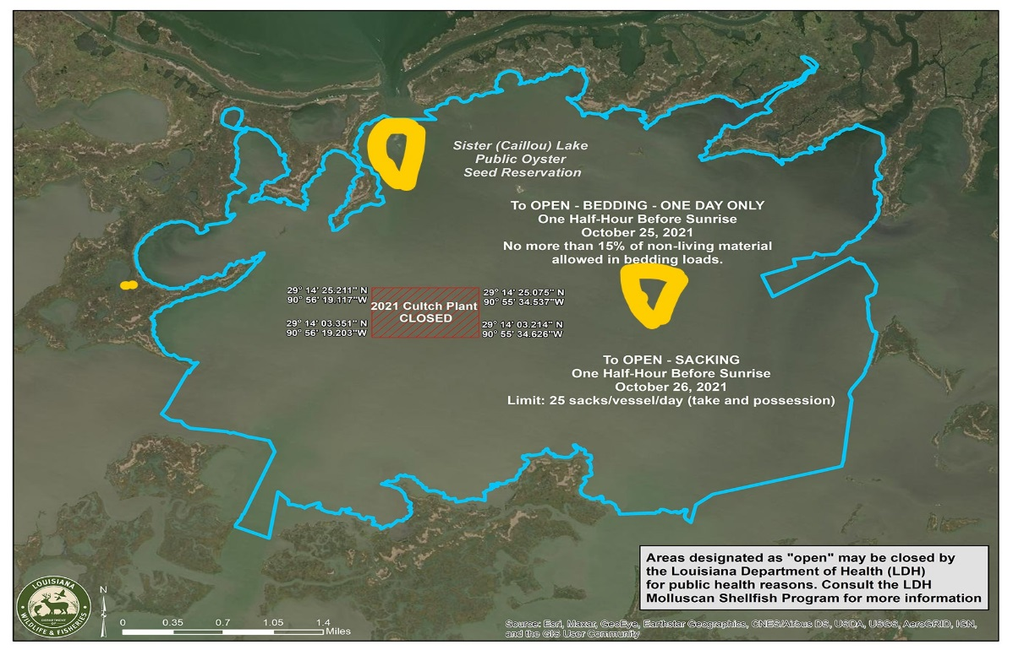
Mitch Jurisich asked if there was any damage to the stock from now since the previous assessment
Carolina Bourque stated that they did not conduct the same type of stock like they did in July, in July square meter samples were taken and after the storm dredge samples were collected. Most of the Lake, the areas that do have live oysters, seed, and sack sized oysters, did not have much debris or mud on top of the reefs so that is why the same dates were maintained for the opening and closing of oyster season
F. The board heard an update on the cooperative endeavor agreement between LDWF and Plaquemines Parish
Cole Garett stated that the unpaid invoices were from before the contract was signed and in place and they are almost 5 years old now
Cole Garrett stated that he will circle back with fisheries staff to see where this stands
VII. Public Comment
George Ricks made a comment on the Failed Bohemia Salinity Control Structure stated that part of the issue is that LDWF is more worried about conforming with the master plan, while the masterplan should be more concerned with conforming with the State’s wildlife and fisheries
Brian Lezina stated that this is the State of LA’s comprehensive coastal plan, is it not the oyster fishermen of Louisiana’s master plan. We have never said that the EIS is wrong, we don’t shy away from the fact that the seafood industries will be impacted
Brad Robin stated that the Caernarvon structure and some of the structures east side of the river-all of what they built, over the last 10 years, was moved by one hurricane, this is not working
VIII. The task force set their next meeting for Tuesday, December 7, 2021 1pm at the Lakefront Airport LDWF Headquarters-2000 Quail Dr., Baton Rouge, LA 70898
The task force stated that they are waiting until a fisheries disaster is declared to have another Public-Private Oyster Seed Grounds Committee meeting- POLR Program
XI. Jakov Jurisic motioned to adjourn, 2nd by Peter Vujnovich. Motion carries.

